# **Software Requirements Specification (SRS)**

**Project Name:** Gestlink **Version:** 1.3 (Wired Comm & LED Grid Update) **Date:** November 27, 2025 **Status:** Research / Comparison Phase

## Version History

| Software Requirement Specification | | |
| --- | --- | --- |
|  | Version 1.0 | 7 Pages |

## **1. Introduction**

### **1.1 Purpose**

The purpose of this document is to define the software and architectural requirements for **Gestlink Version 1.0**. This version focuses on the "Core Loop" of the product: accurately identifying hand gestures in an industrial environment, providing immediate feedback to the worker, and transmitting the command to a central control system.

### **1.2 Scope**

Gestlink is a contactless control interface designed for heavy industry. It replaces physical buttons and touchscreens with **Air Gestures**, allowing workers to operate machinery without removing protective safety gloves. The V1.0 system includes:

1. **Sensing:** Detection of hand movements.
2. **Feedback:** Immediate user confirmation (Visual Patterns via LED Grid).
3. **Communication:** Reliable wired transmission of commands to the backend.

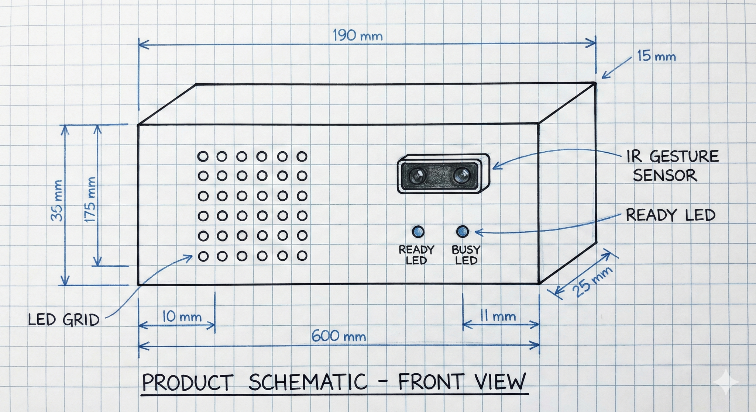

## **2. Technology Trade-off Analysis**

*This section compares available Industry 4.0 technologies evaluated for the Gestlink architecture.*

### **2.1 Sensor Technology Comparison**

The following sensor types were evaluated for "Gloved Gesture Recognition."

| **Feature** | **Optical Camera** | **IR Camera (Infrared)** | **Ultrasonic Sensor** | **mmWave Radar** |
| --- | --- | --- | --- | --- |
| **Lighting** | Fails in low light / darkness. | Works in darkness. | Works in darkness. | **Works in darkness.** |
| **Environment** | Lens gets blocked by oil/dust. | Lens gets blocked by oil/dust. | Affected by loud factory noise. | **Unaffected by dust, oil, or noise.** |
| **Privacy** | High concern (records faces). | Moderate concern (thermal/depth). | No concern. | **No concern (no images).** |
| **Glove Use** | Hard to track black gloves. | Good (detects heat/depth). | Good (detects distance). | **Excellent (penetrates glove material).** |
| **Precision** | High (Spatial). | High (Spatial + Depth). | Low (Distance only). | **High (Velocity & Range).** |

### **2.2 Communication Protocol Comparison**

The following standard industrial protocols were evaluated for Edge-to-Backend communication.

| **Feature** | **HTTP (REST)** | **CoAP** | **OPC UA** | **MQTT** |
| --- | --- | --- | --- | --- |
| **Transport** | TCP (Heavy). | UDP (Unreliable). | TCP (Heavy). | **TCP (Lightweight).** |
| **Architecture** | Request/Response (Polling). | Request/Response. | Client/Server (Complex). | **Pub/Sub (Event-Driven).** |
| **Packet Overhead** | Huge (Headers). | Tiny. | Large (XML/Binary). | **Tiny (2-byte header).** |
| **Reliability** | Good. | Poor (Packet loss risks). | Excellent. | **Excellent (QoS 1 & 2).** |
| **Suitability** | Web Dashboards. | Battery Sensors. | Heavy Machinery. | **Event-based Control.** |

### **2.3 User Feedback Mechanism Comparison**

The following mechanisms were evaluated for confirming user input in an industrial setting.

| **Mechanism** | **Haptic (Vibration)** | **Audio (Buzzer)** | **Visual (LED Grid)** |
| --- | --- | --- | --- |
| **Implementation** | Difficult (Requires smart glove). | Simple. | **Moderate (Matrix Driver).** |
| **Clarity** | High (if wearing glove). | Low (Factory noise masks it). | **High (Pattern Recognition).** |
| **Cost** | High. | Low. | **Low/Medium.** |

## 

## **3. System Architecture**

### **3.1 Data Flow Diagram**

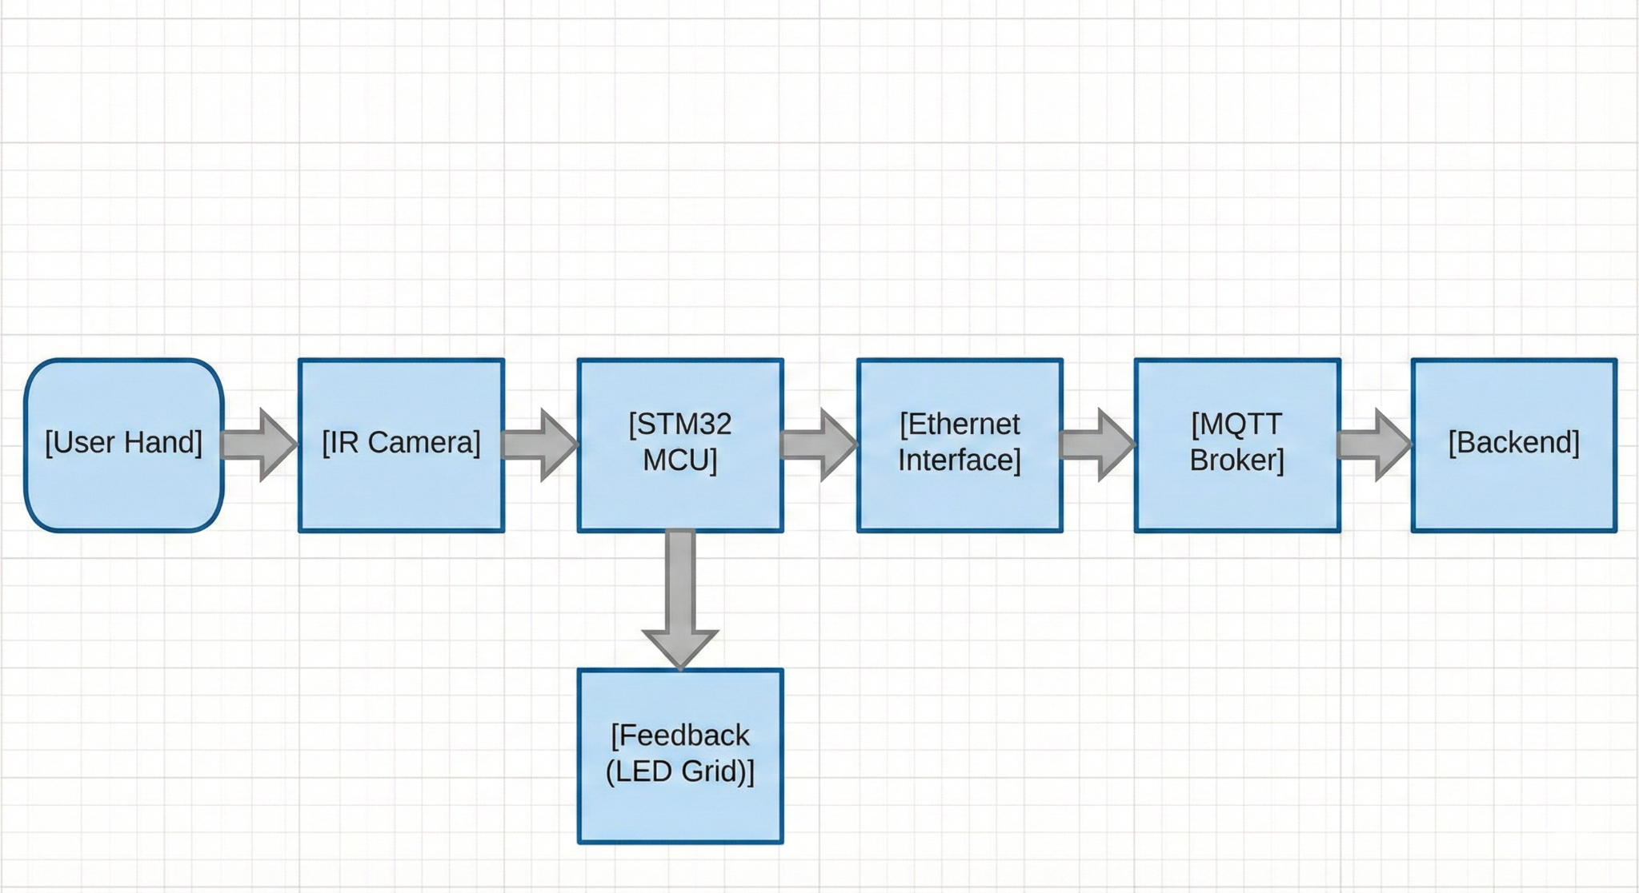

## **4. Functional Requirements (Core V1)**

### **4.1 Module 1: Gesture Identification**

| **ID** | **Requirement** | **Description** |
| --- | --- | --- |
| **FR-01** | **Core Gestures** | The system must recognize 4 distinct gestures:  1. **Swipe Left** (Previous)  2. **Swipe Right** (Next)  3. **Push** (Select/Actuate)  4. **Hold/Palm** (Stop) |
| **FR-02** | **Detection Zone** | Gestures must only be registered within a configurable "Active Box". The system must provide a calibration mode to set the min/max depth (Z-axis) to filter out background movement. |
| **FR-03** | **Confidence Threshold** | The system must discard any gesture recognition with a confidence score below 85% to ensure safety. |

### **4.2 Module 2: User Feedback (The Interface)**

| **ID** | **Requirement** | **Description** |
| --- | --- | --- |
| **FR-04** | **Idle State** | When waiting for input, the LED Grid must display a **"Scanning"** animation (e.g., a single pixel moving across the perimeter) to indicate the system is active. |
| **FR-05** | **Success State** | Upon valid gesture detection, the LED Grid must display the corresponding icon for 500ms:  1. **Swipe Left:** Left Arrow (<)  2. **Swipe Right:** Right Arrow (>)  3. **Push:** Filled Square (■)  4. **Hold:** Stop Sign/Octagon |
| **FR-06** | **Error State** | Upon invalid/low-confidence gesture, the LED Grid must display a blinking **"X"** pattern for 500ms to indicate rejection. |

### **4.3 Module 3: Communication**

| **ID** | **Requirement** | **Description** |
| --- | --- | --- |
| **FR-07** | **Topic Structure** | Data must be published to a hierarchical topic: Gestlink/factory_floor/{machine_id}/command. |
| **FR-08** | **Payload Format** | Messages must use JSON format. Timestamps must be in UTC ISO 8601 format or Unix Epoch Milliseconds.  Example: { "gesture": "swipe_left", "confidence": 0.92, "timestamp_ms": 1712045600123 } |
| **FR-09** | **QoS Level** | All control commands must be sent with **QoS 1 (At Least Once)** to ensure the backend receives them even if network interruptions occur. |

## **5. Non-Functional Requirements**

### **5.1 Performance**

* **Latency:** The time from "Gesture Complete" to "MQTT Publish" must be **< 100ms**. Total system latency (to Machine) must be **< 250ms**.
* **False Positives:** The system must not trigger a command from random environmental movement (e.g., a person walking behind the operator).

### **5.2 Environmental**

* **Temperature:** Industrial environments usually maintain temperatures in the range of **20°C to 24°C**. Certain high-temperature industrial processes may exceed this range, but for general operation and equipment safety, this is a common control range.
* **Moisture and Humidity:** Relative humidity is generally kept between **30% and 60%**. Excessive moisture can damage electrical equipment and affect product quality.
* **Dust:** Dust levels vary widely depending on industry type, but dust concentration in clean industrial environments is ideally kept below **0.1 mg/m³** to avoid contamination and equipment wear.
* **IP Rating:** The sensor enclosure must be designed to **IP65 standards** (dust protected / splash proof).
* **Vibration:** The radar mounting must dampen machine vibrations to prevent sensor noise.

### **5.3 Electrical Characteristics**

* **Voltage and Current:** Operating voltage and current depend on specific machinery requirements. Typically, industrial machines operate on voltages from **220V single phase to 480V three-phase**, with current ratings varying according to power consumption. The Gestlink Edge Unit must be compatible with these industrial power environments (via appropriate step-down converters).

## **6. Interface Specifications**

### **6.1 Hardware Interfaces**

* **IR to MCU:** UART (High baud rate: 921600 bps) for point cloud data.
* **MCU to Feedback:**
  + SPI or I2C for LED Grid Driver (e.g., MAX7219 or IS31FL3731).
* **Network Interface:** Ethernet (RJ45 or Industrial M12 connector) supporting 10/100 Mbps.

### **6.2 Software Interfaces**

* **MQTT Broker:** Mosquitto (Port 1883).
* **Fail-Safe Mode:** If the connection to the MQTT Broker is lost for > 2000ms, the system must enter a "Safe State" (LED Grid displays specific "Offline" icon) and disable gesture inputs.

**End of Document**